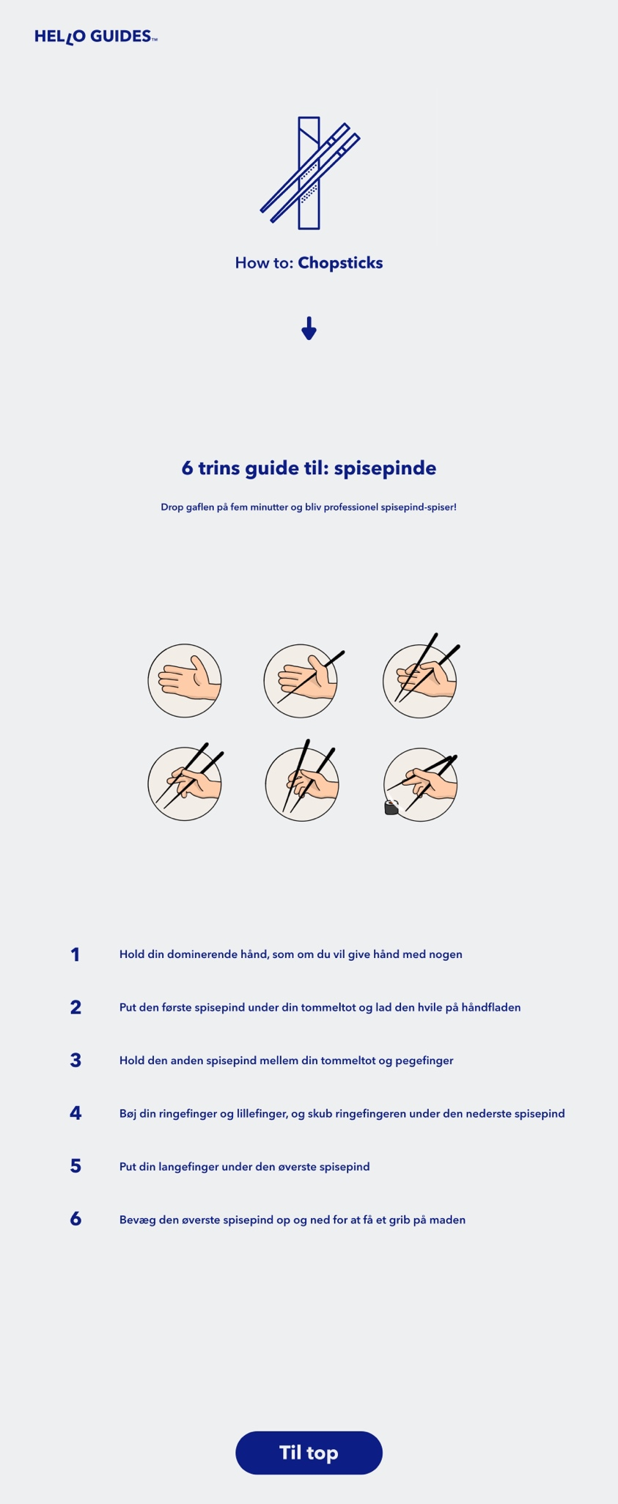

Ordered list

Footer

Bookmark

Section

Img

Img

Img

Paragraf

H2

Main

H1

Article

Header

Nav

Anker